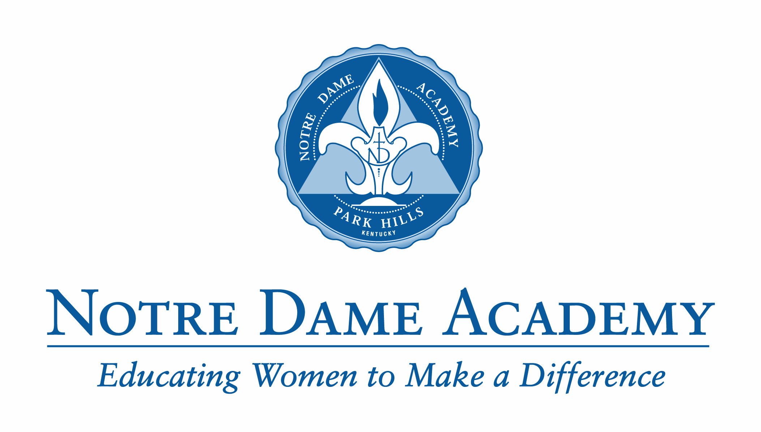

Class of 2014

Alisa Michele Arlinghaus
Mariah Marie Asbury
Kellie Maria Barker
Emily Anne Bautista
Megan Ann Berberich
Monica Lynn-Hai Berling
Mary Claire Bessler
Holly Elizabeth Birrer
Rachel Emma Birrer
Melanie Katherine Boehmer
Sara Marie Borchers
Morgan Nicole Bosley
Ashley Nicole Bowdy
Anna Gail Bradtmueller
Allison Elise Bridwell
Madeline Frances Buring
Ashley Mae Burnett
Kendall Alyssa Burwick
Ana Cristina Calvopina
Vanessa Thuc Nghi Cao
Carlee Marie Clemons
Alexa Stewart Colvin
Kylie Ann Colvin
Ellen Marie Combs
Heather Noel Craig
Caren Ann Curk
Allison Gail Darpel
Kendall Elizabeth Darpel
Jenna Lynn Davenport
Hayleigh Marie Deininger
Hannah Grace Dietz
Ashley Nicole-Taylor Donovan
Rachel Marie Driehaus
Jenna Cecelia Eby
Carlie Elyse Eckerle
Kathryn Jill Edgington
Tessa Grace Farrar
Mary Ellen Fathman
Katherine Hope Fedders
Laura Elizabeth Finke
Maggie Irene Flanagan
Elizabeth Marie Fley
Breanna Katherine Flynn
Moriah Theresa Louise Frommeyer
Megan Elizabeth Gamel
Kelsey Christine Gearns
Leah Michelle Gerding
Bridget Ann Gerrety
Ashley Rae Gettelfinger
Elizabeth Anna Ginter
Kelly Alexandra Graham
Ashleigh Jane Grant
Stephanie Marie Hacker
Mary Margaret Hackman
Rachel Ann Hardin
Kaylee Michelle Harrison
Hannah Jane Hatch
Morgan Kimberly Heimbrock
Savannah Marie Hemmer
Avery Ann Henderson
Frances Mary Katherine Herbe
Libby Ann Hinken
Lauren Ruth Hollman
Sydney Nichole Humphrey
Allyson Lissette Iglesias
Emma Lee Jacobs
Rachael Clair Jeffrey
Kelly Marie Kathman
Paige Marie Kellam
Molly Lynn Kirn
Paxton Darby Kirpes
Meredith Joan Klare
Kathleen Mary Klensch
Szofia Elizabeth Komaromy-Hiller
Christina Rose Kossenjans
Mary Katherine Magdalen Kramer
Lindsey Marie Kruer
Caroline Elizabeth Krumme
Olivia Jane Kuykendall
Jessica Lee Lankheit
Sidney Marie Lenhof
Margaret Ann List
Olivia Kirsten Lyon
Amanda Carol Macke
Julianna Marie Macke
Abby Fay Marshall
Abigail Grace Martin
Sarah Elizabeth Massman
Kathryn Eileen Maurer
Molly Ann Mayer
Maggie Ann McLeod
Amanda Olivia Meagher
Abby Elizabeth Meiners
Kelsey Marie Michael
Emily Nicole Mihalovich
Caroline Rose Miller
Bridget O’Halloran Minks
Maria Grace Nacu
Sarah Therese Noll
Erin Elisabeth Nurre
Elizabeth Ann Ogle
Abby Elizabeth ONeill
Hope Maria Anna Pauly
Morgan Elizabeth Read
Dorothy Abbigail Rees
Olivia Ann Reinert
Abigail Lynn Roebker
Olivia Nicole Roettker
Madison Lynne Rose
Jane Su Rudnick
Sara Grace Russo
Olivia Mackenzie Scaringi
Maria Katharina Schaefer
Summer Elizabeth Scheben
Rebecca Anne Scheper
Emma Marie Schneider
Kellyanna Christine Ruth Schneider
Kristen Marie Schneider
Jacqueline Lee Schuh
Alexa Rae Schulte
Meredith Catherine Schulte
Katherine Alice Schweitzer
Molly Jane Seiter
Marisa Anne Smith
Sandra Elizabeth Steiber
Alexandra Maria Steigerwald
Bridget Lynn Stewart
Emily Anne Stoeckle
Zoe Kathryn Stovik
Hanna Elizabeth Sullivan
Meagan Danielle Sullivan
Allison Louise Sweitzer
Kristen Marie Tabeling
Molly Adelaide Talkers
Kiara Francesca Tasayco
Heidi Ellen Thelen
Summer Marie Thompson
Madeline Grace Tierney
McKenzie Elizabeth Trentman
Rachael Marissa Victoria
Kasi Patricia Vignale
Jessica Margaret Vogt
Brianna Danielle Vollman
Kylie Elizabeth VonHandorf
Nicole Frances Waugaman
Lillian Louise Graham Weber
Emma Catherine Wehrman
Madeline Therese Weltzer
Abby Christine Wendt
Morgan Taylor West
Erin Gabrielle White
Allison Jean Wildt
Clara McKenna Wood
Hayley Marie Zeis
Meredith Kate Ziegelmeyer
Hannah Marie Ziegler
Abigail Marie Zimmerman
Olivia Leigh Zimmerman

